Public
BSC Change Business Requirements
P379 ‘Enabling consumers to buy and sell electricity from/to multiple providers through Meter splitting’

Shamaila Jawaid
V0.3
[15 November 2019]

Document History
Date | Version | Author | Reviewers | Description
 | V0.1 | Shamaila Jawaid | Peter Frampton, John Lucas, Aditi Tulpule, Fungai Madzivadondo, Paulina Stelmach | Initial draft
 | V0.2 | Shamaila Jawaid | Peter Frampton, John Lucas, Aditi Tulpule, Fungai Madzivadondo, George Player  P375 and P376 teams | Updated to address comments
 | V0.3 | Shamaila Jawaid / Peter Frampton

Approvals
Date | Name | Role

Contents
Document History 2
Approvals 2
1. INTRODUCTION 4
1.1 Purpose 4
2. BSC Change Summary 4
2.1 BSC Change P379 Problem Statement 4
2.2 BSC Change P379 Objectives and scope 4
2.3 Architecture Fit 5
2.4 References 6
3. BUSINESS REQUIREMENTS 8
3.1 Current State (As-Is situation) 8
3.2 Changes to be introduced 8
3.3 Future State 9
3.4 Business Requirements 9
Summary of obligations 10
3.5 Business Rules 44
3.6 Business Scenarios 44
3.7 Data Relationships 44
4. GLOSSARY 45
5. APPENDIX A P375 RequirementsMetering Requirements for Asset Meters 46
5.1 Metering requirements for asset meters 46
5.2 Requirements to be replaced 46

INTRODUCTION

Purpose
The BSC Change Business Requirements document is produced as part of the ‘End to End BSC Change Process’ during the BSC Change Assessment process.
The purpose of this document is to communicate the Business Requirements of BSC Change P379 to industry members and service providers. It enables an initial impact assessment to be carried out by a Service Provider.
In addition it describes the anticipated impact on BSCCo (people, processes and systems), the BSC, Code Subsidiary Documents, and other Configurable Items.

BSC Change Summary

BSC Change P379 Problem Statement
The BSC does not enable the splitting of volumes supplied or exported by two or more different suppliers of electricity through a single Meter without the concerned suppliers having to enter into an agreement which they must re-establish if the Customer decides to utilise any other supplier not in the agreement, for any purpose.
A successful solution must enable multiple suppliers and different types of suppliers (e.g. Electric Vehicle Suppliers, Community Energy Schemes, exempt suppliers) to compete for the supply or export of electricity through a single Meter without needing to establish an agreement between any of the suppliers involved.
The solution should ensure any code provisions and procedures are not an obstacle to participation and must ensure that each meter registrant’s imbalance position is not materially and adversely impacted by other suppliers operating across the meter. All relevant calculations to achieve the solution must be reasonable and should be achieved in a timely manner.

BSC Change P379 Objectives and scope
Modification P379 aims to achieve the following objectives:
- Enable multiple suppliers to supply electricity to a single customer (behind a single Boundary Point) without the need for a prior agreement.
- Each meter registrant’s imbalance position is not materially and adversely impacted by other Suppliers operating across the meter.
It defines the rules for the following by building on existing solutions and capabilities in place for P344 ‘Project TERRE’, P354 ‘ABSVD’, P375 ‘Metering behind the Boundary Point’.
- Introducing a new BSC Party: Contract Notification Agent (CNA);
- Associating meter information: enabling metering systems (both at the boundary point and behind the boundary point) to be associated with multiple BM Units;
- Registering meter information: enabling behind-the-meter metering systems to be registered by a Supplier
- Notifying Parties of multiple supply activities in a timely manner;
- Obtaining metered volumes;
- Applying contract volume notifications;
- Splitting the boundary point metered volumes and allocating the correct volumes to each Party;
- Reporting on multiple supply activity; and
- Providing performance assurance.

Architecture Fit
P379 proposed solution builds on the business capabilities that are being enhanced for P344 and P375, particularly around registration and validation of assets and meters behind the boundary point.
Similarly, the technical capabilities required manage split meter volumes, if a requirement of SVAA, should be based on those developed for SVAA in support of P344 and P375.
The following capabilities and business processes within the BSC are impacted by P379.
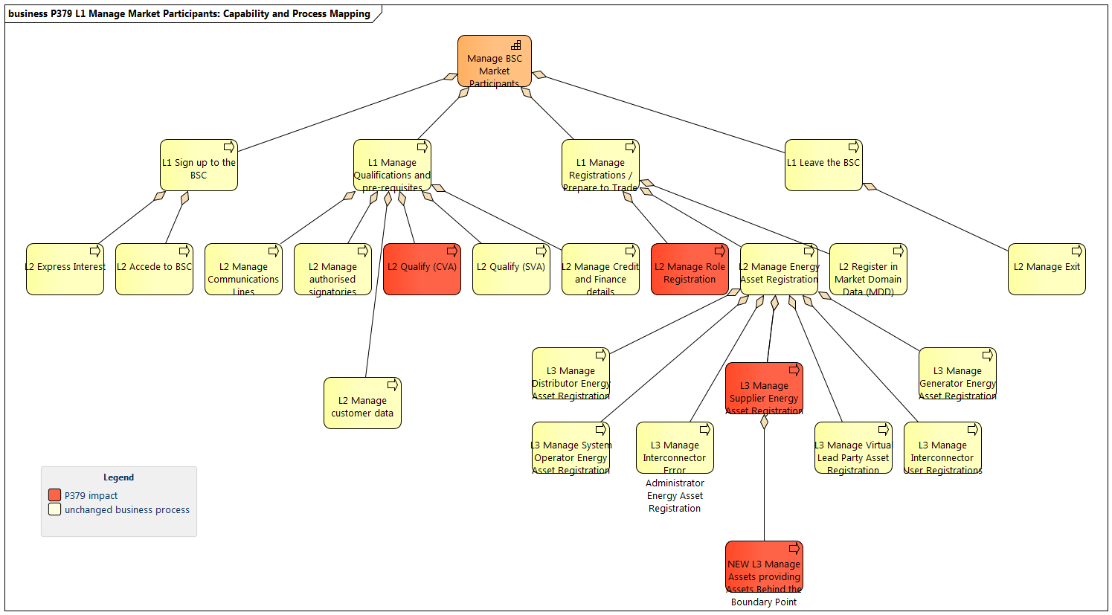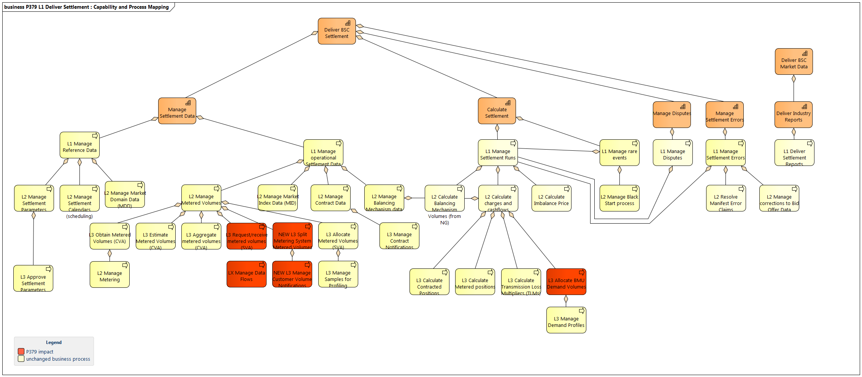

References

Document | Author | Date
Workgroup (WG) Slides | ELEXON
P344 Business Requirements v5.0 | ELEXON
P375 Business Requirements v1.0 | ELEXON | 02 Sept 2019
P376 Business Requirements (draft) | ELEXON

BUSINESS REQUIREMENTS
This section sets out the Business Requirements of P379 as defined during the Assessment Procedure.

Current State (As-Is situation)
Shared SVA Metering Arrangements (pre-agreed arrangements between suppliers for meter splitting)
Currently, the SVA Shared Metering Arrangements as set out in BSCP550 ‘Shared SVA Meter Arrangements’ enable two or more Suppliers to split the volumes at an Metering System Identifier (MSID) in accordance with a pre-agreed allocation schedule or by using a non-settlement meter located ‘behind’ the boundary MSID. A pseudo Secondary MSID is created by the Licensed Distribution System Operator (LDSO) for the Secondary Supplier to enable this to work. It enables Parties to revise the allocation schedule up until Gate Closure. The appointed HHDC of the Primary Supplier is responsible for collecting and validating the metering data for the physical Shared SVA Metering System between the Primary MSID and the pseudo Secondary MSID(s) in accordance with the method specified in the Allocation Schedule.

Project TERRE (use of MSID level data in Settlement and the association of MSID Pairs with other Parties with the relationships held in a Balancing Services Register)
BSC Modification P344 “Project TERRE implementation into GB market arrangements” has enabled Parties to participate in Balancing Services such as Bid-Offer Acceptances or the Replacement Reserve Balancing Services Product at the MSID level.
P344 has created a new Party type ‘Virtual Lead Party (VLP)’ that can register Boundary Point MSIDs against Secondary BM Units (virtual BM Units also registered by VLPs) for the purposes of delivering Balancing Services. A Secondary BM Unit will contain MSIDs registered by another Supplier. The SVAA validates the information provided by the VLP and upon successful registration, it then instructs the MSID registrant’s HHDA to report Metered Volume data for a given MSID in line with the SVAA calendar.
VLPs must provide the Delivered Volumes to SVAA for adjustment of the Supplier Imbalance position and calculation of non-delivery of the instructed volumes for TERRE Replacement Reserve. SVAA then aggregates both Metered Volume and Delivered Volume data and passes it on to SAA, which in turn adjusts the Imbalance Position of the BSC Party who is the Registrant of the Boundary Point MSID used by the VLP.
P344 introduces the concept of a Balancing Services Register that enables MSID Pairs to be linked to Virtual Lead Parties, their primary Suppliers and the relevant agents. SVAA holds a central register of MSIDs that are registered against Secondary BM Units for all VLPs.

Changes to be introduced
Metering Behind the Boundary Point (use of associated MSID Pairs in Settlement, relationships managed via the Balancing Services Register)
The market is seeing new business models with diverse and smaller scale assets such as EV chargepoints and domestic appliances. These smaller assets tend to share a site with other demand and generation assets, whose flows are all measured and then settled using the Boundary Point MSID. When providing a balancing service it is necessary to submit a Physical Notification to the NETSO. The Physical Notification is a forecast of flows for the relevant settlement period. This Physical Notification turns final (FPN) at gate closure and is used by the NETSO to dispatch the asset and is subsequently used in the Settlement of the Balancing service.
If this FPN is inaccurate, it can lead to Imbalance and/or Non-delivery charges in settlement. As the Boundary Meter measures total flows for the site and not just the asset, Virtual lead Parties (VLPs) have difficulties in being able to forecast the FPN accurately which they state is a significant blocker to the provision of Balancing Services. This creates a need to allow Settlement to acquire data from metering behind the Boundary Point, i.e. at the asset, which is delivering the Balancing Service. By allowing this, the VLP can install metering or use existing metering which can isolate the flows to a specific asset, which the VLP can therefore forecast accurately in its FPN.
The process for collecting and aggregating Metered Volume data for Assets located behind the Boundary Point is being introduced by Modification P375 ‘Metering behind the Boundary Point’. P375 builds on the P344 solution by enabling data to be held about Assets behind the Boundary Point MSID, these will be known as Asset Metering System Identifiers (AMSIDs)’. The P375 solution extends the capabilities of the Balancing Services Register to include providing and keeping a record of AMSIDs and identifies the metering standards and requirements for AMSIDs. It also defines the processes used for instructing agents and requesting metered volumes for AMSIDs.
AMSID Pair metered volumes are held in both Secondary BM Units and Primary Supplier Base BM Units. The Settlement Administration Agent (SAA) adjusts the balancing services volume during the relevant Settlement Run.

Future State
P379 introduces the ability to split a boundary point meter reading by subtracting metered volumes for assets behind the meter and/or splitting volumes by a percentage or fixed amount allocated to the suppliers involved in meter splitting. It builds on the capabilities introduced by P344 ‘Project TERRE’ and P375 ‘Metering Behind the Boundary Point’ in particular the use of metering system level data and the storing of these relationships with Parties and BM Units associated with these metering systems.
There are several options for a BSC solution to enable P379. The key difference between two solutions discussed so far at the Workgroup meetings is that in the proposed the SVAA calculates the meter splitting and in the alternative, the Primary Supplier’s HHDC is responsible for meter splitting.
The diagram below summarises the key changes made by P379. Orange indicates a new process and teal indicates existing processes.
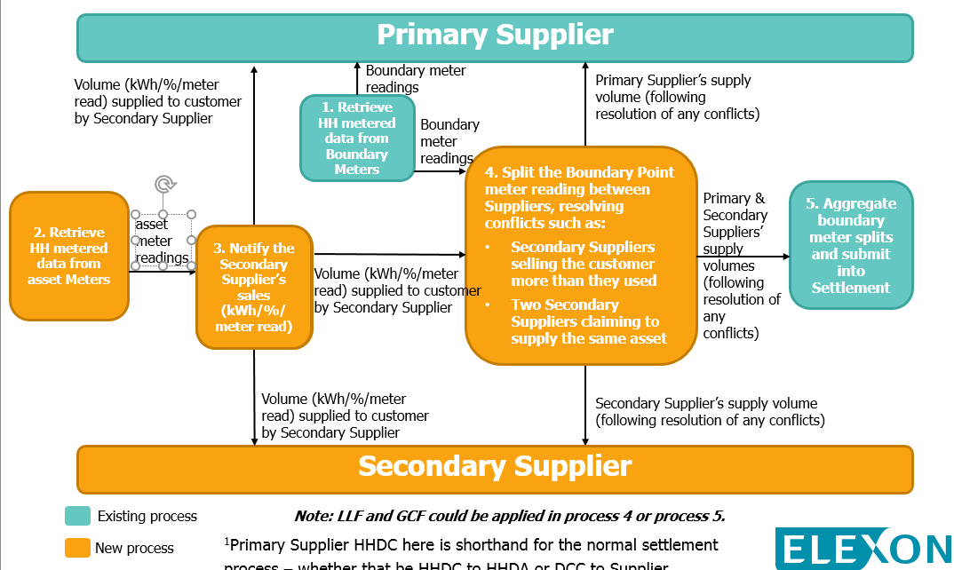

Business Requirements
The business requirements are grouped by the following areas within the settlement lifecycle to achieve the outcome of correct volumes for each party. Each requirement is stated at high-level and additional description is provided where necessary. Requirements are labelled to indicate whether they apply to the proposed solution option, alternative solution option or both.

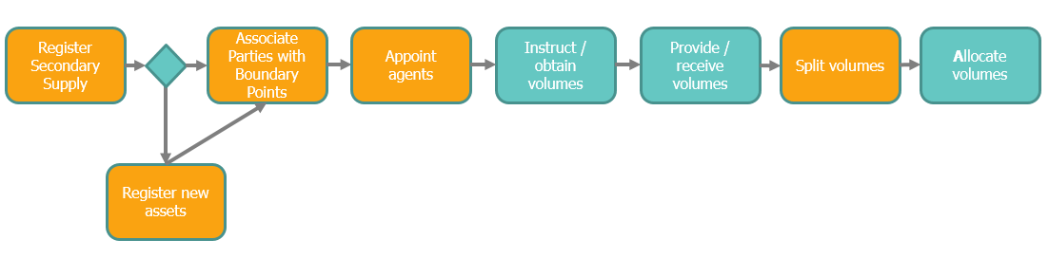
Orange boxes indicate a change to existing arrangements and teal indicates existing processes.
The P379 solution uses many of the capabilities introduced by P375 ‘Metering behind the Boundary Point’ which is currently undergoing the BSC Change Assessment phase. To ensure alignment, requirements from P375 have been re-used and applied for P379 where applicable and marked as re-used.

Summary of obligations
Role | Key focus / obligation
Primary Supplier | Receives notifications of Secondary Supply at the boundary point, behind the boundary point metered volumes and Primary Supplier’s share of the metered volume that has been split
Secondary Supplier | Notifies sales of Secondary Supply to CNA, notifies change of occupier at a Boundary Point MSID, receives notification of activity at the boundary point other than the Secondary Supplier and Secondary Supplier’s share of the metered volume that has been split
PS Half Hourly Data Collector (PS HHDC) | Obtain Boundary Point MSID metered volumes  Receive Secondary Supplier’s AMSID Pair metered volumes and calculate split [alternative]
SS Half Hourly Data Collector  (SS HHDC) | Obtain and provide metered volumes for AMSID Pairs behind the Boundary Point
PS Half Hourly Data Aggregator  (PS HHDA) | Provide Boundary Point MSID Pair metered volumes to calculation entity [proposed]
Customer Notification Agent (CNA) | Convert sales of Secondary Supply into Settlement data and provide to calculation entity (SVAA or Primary Supplier’s HHDC)  Resolves any conflicts in customer volume notifications before providing to the calculation entity
BSC Central Systems  (SVAA) | Notify and split boundary point metered volumes [proposed]  Allocate volumes to each Supplier as per existing processes  Request/instruct Primary Supplier’s Half Hourly Data Aggregator to provide metered volumes for the Boundary Point MSID Pairs  Manage AMSID registrations (if agreed)

Register (Party / Party Agents)
This section introduces Secondary Supply and the applicable roles.
Pre-requisites
- The Secondary Supplier must register its Balancing Mechanism Units (BMU) (as per existing processes)
To register a new AMSID, see 3.4.2 Register new sites (AMSID Pair registration)

Ref. no | Business Requirement
P379-BR1 Party requirements
P379-BR1 | P379-BR1.1 Suppliers must be able to provide Secondary Supply in the following ways:  If a Supplier chooses to provide Secondary Supply to a customer, they may do so in the following ways:  - BR1.1 (a) Asset based Supply (e.g. an electric vehicle)  - BR1.1 (b) Fixed volume of Secondary Supply at the Boundary Point  - BR1.1 (c) Percentage volume of Secondary Supply at the Boundary Point  Throughout this document a Supplier providing Secondary Supply will be referred to as a Secondary Supplier. The concept of Secondary Supply can be applied equally to a boundary or asset meter, where the asset meter acts as the Boundary Point meter if its meter reading is to be split between multiple Secondary Suppliers.  [proposed & alternative]
P379-BR1.2 A new Customer Notification Agent (CNA) will be introduced

Requirement Description

[proposed & alternative] P379 will introduce the following Party type: Customer Notification Agent (CNA). The purpose of the CNA would be to notify the calculation entity (proposed: SVAA; alternative: Primary Supplier’s HHDC) of the % or fixed volume of Secondary Supply at the Boundary Point.
P379-BR1.3 the CNA will need to qualify in its role

Requirement Description

[proposed] The CNA must be subject to SVA qualification as it will provide volume notifications to SVAA. The qualification requirements should be materially similar to those of an Energy Contract Volume Notification Agent (ECVNA) and Metered Volume Reallocation Notification Agent (MVRNA) in respect of the notifications those agents sent to the Energy Contract Volume Allocation Agent (ECVAA)

[alternative] The CNA must be subject to SVA qualification as it will provide volume notification to the Primary Supplier’s HHDC. The qualification requirements should be materially similar to those of an Energy Contract Volume Notification Agent (ECVNA) and Metered Volume Reallocation Notification Agent (MVRNA) in respect of the notifications those agents sent to the Energy Contract Volume Allocation Agent (ECVAA).

P379-BR1.4 Secondary Suppliers must register asset metering behind the boundary point meter as AMSID Pairs.

Requirement Description

[proposed & alternative] If an AMSID Pair does not exist for the asset, the Secondary Supplier must be able to request an AMSID from the Secondary Supply registration agent and register it within an AMSID Pair. See requirement P379-BR5 below. The AMSID Pair must be associated with at least one Boundary Point MSID (MSID Pair if present).

P375- enables a VLP to register asset metering, P379 opens this up to Suppliers.

The Secondary Supply registration agent will be the entity where a register of MSID Pairs, AMSID Pairs, BM Units, Suppliers and appointed agents for the purposes of providing asset meter volumes.

Technical solution consideration: the SVAA Balancing Services Register currently holds this info, and would be used as a starting point.

SVAA acts as a Secondary Supply registration agent in the P375 solution, and therefore P379 can re-use this capability.

Alternatively, the Central Switching Service (CSS) is a candidate to act as the Secondary Supply registration agent.

Party and Asset relationships
This section covers the new asset relationships that must be in place for P379.
Ref. no | Business Requirement
P379-BR2 Party and Asset relationships
P379-BR2 | P379-BR2.1 The solution must create and maintain a register of asset meters. We expect this to be maintained by the SVAA or another Secondary Supply registration agent.  [proposed & alternative]  Re-use of P375-BR1, where this register is the Asset Meter Central Register (AMCR) maintained by SVAA in the P375 solution.
P379-BR2.2 Secondary Supply registration agent must store the following information.

Requirement Description

[proposed & alternative] Within the Secondary Supply registration agent, the asset management entity must be able to receive and store details of all Asset Metering Systems (AMS) (past and current) registered by Primary Suppliers, Secondary Suppliers or Virtual Lead Parties (VLPs).

The details (data) to be stored:
Import/Export AMSID (if asset based)
Half Hourly Data Collector (HHDC) Id (MPID) for Import AMSID/Export AMSID
AMSID pair Effective from Date
AMSID pair Effective to Date
HHDC Effective from Date
HHDC Effective to Date
Meter Operator Id (MPID) for Import AMSID/Export AMSID (where applicable)
MOA Effective from Date (where applicable)
MOA Effective to Date (where applicable)
Associated Supplier Boundary Point Import MSID(s)/MSID Pair
The connection voltage at the Asset Meter System
The connection voltage at the Supplier Boundary Point MSID
Balancing delivery capacity of the asset in kW [P375 only]
Asset type (e.g. diesel generator, battery storage unit, Electric Vehicle charging unit) [P375 only]
Line Loss Factor Class (LLFC)
Consumption Component Class Id (CCC Id)
AMS make and model
AMS IEC standard
Asset Meter Serial Number
MOA alternative used
AMSID GSP Group Id
Secondary Supplier Supplier ID
Secondary Supplier BMU ID
Supplier BMU-AMSID relationship Effective from date (if asset based)
Supplier BMU-AMSID relationship Effective to date (if asset based)
CNA (if not asset based)
Secondary Supplier BMU and asset relationship effective from date
Secondary Supplier BMU and asset relationship effective to date
The MSID of the Import Metering System
The MSID of the Export Metering System (where applicable)
The MSID Pair Effective From Settlement Date
The MSID Pair Effective To Settlement Date
A Import Metering System Customer Consent Flag
A Import Metering System Customer Consent Flag Effective From Settlement Date
A Import Metering System Customer Consent Flag Effective To Settlement Date
A Export Metering System Customer Consent Flag
A Export Metering System Customer Consent Flag Effective From Settlement Date
A Export Metering System Customer Consent Flag Effective To Settlement Date

Re-use of P375-BR2
P379-BR2 | P379-BR2.3 The solution must enable the relationships provided in Section 3.7 ‘Data Relationships’. Key relationships are highlighted in the following business requirements.  P379-BR2.4 The solution must enable AMSID Pairs to be associated with Boundary Point MSID Pairs.  Requirement description  [proposed & alternative] It must be possible to associate an AMSID Pair with an existing Boundary Point MSID Pair.  For new sites please see section 3.4.5 ‘Register AMSID Pairs for new and existing assets’.  P379-BR2.5 The solution must enable MSID Pairs to be associated with a Supplier’s BM Unit.  Requirement description  [proposed & alternative] It must be possible to associate an MSID Pair with an existing Supplier’s Base or Additional BM Unit for the purpose of Secondary Supply. The association must not result in any automatic allocation of volumes from the associated MSID to the BMU.  The association must not confer any responsibilities to the associated Supplier with respect the function or assurance of the function of the Metering Equipment associated with the MSID.  P379-BR2.6 The solution must enable AMSID Pairs to be associated with a Supplier’s BM Unit.  Requirement description  [proposed & alternative] It must be possible to associate an AMSID Pair with an existing Supplier’s Base or Additional BM Unit.  P379-BR2.7 The solution must enable Suppliers to disassociate an AMSID Pair from its Supplier BM Unit  Requirement description  [proposed & alternative] It must be possible for a Supplier to disassociate an AMSID Pair from its Primary BM Unit or Additional BM Unit.

Register Secondary Supply
This section covers the requirements for registering Secondary Supply. The map below provides a brief overview of secondary supply registration. See section 3.4.5 for registering new AMSID Pairs.
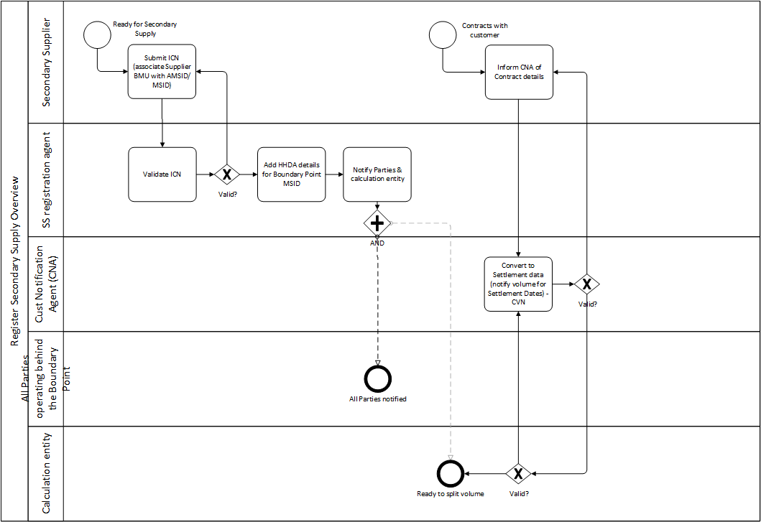
Ref. no | Business Requirement
P379-BR3 Register Secondary Supply
P379-BR3 | P379-BR3.1 Secondary Supplier must associate the MSID Pair for which it’s providing Secondary Supply with its BMU and notify the Secondary Supply registration agent at least [1] WD before commencing supply to the asset.  Requirement description  [proposed & alternative] The Secondary Supplier must associate the MSID Pair to which it is providing Secondary Supply with its Supplier Base or Additional BMU and notify the Secondary Supply registration agent.  This notification is the Initial Customer Notification (ICN). The contents of the ICN is as follows:  - Secondary Supplier Supplier ID  - Secondary Supplier BMU ID  - Supplier BMU-AMSID relationship Effective from date (if asset based)  - Supplier BMU-AMSID relationship Effective to date (if asset based)  - CNA (if not asset based)CNA  - Import AMSID (if asset based)  - Export AMSID (if asset based)
P379-BR3.2 The Secondary Supply registration agent must validate details provided in the ICN

Requirement description
[proposed & alternative]
The [Secondary Supply registration agent] must validate the following in the ICN:

- the effective dates are in future [accept if ‘yes’; reject if ‘no’]
- The AMSID Pair has been registered by a Supplier or VLP [accept if ‘yes’; reject if ‘no’]
- AMSID and BMU are in the same GSP Group [accept if ‘yes’; reject if ‘no’]
- AMSID is associated with at least one Boundary Point MSID [accept if ‘yes’; reject if ‘no’]
- The associated Boundary Point MSIDs are registered within SVAA/other register [accept if ‘yes’; reject if ‘no’]
- Do the AMSID - BP MSID relationships match what exists in SVAA/other register? [accept if ‘yes’; reject if ‘no’]

P379-BR3.3 The Secondary Supply registration agent must inform successful registration of Secondary Supply via AMSID to the Secondary Supplier via a formal notification.

Requirement description

[proposed & alternative] Upon validation, if all validation against the rules from BR3.2 result in accept, then the Secondary Supply registration agent confirms successful registration of Secondary Supply to the Secondary Supplier via a formal notification (P0279 or similar)

P379-BR3.4 The Secondary Supply registration agent must inform unsuccessful registration of Secondary Supply via AMSID to the Secondary Supplier via a formal notification.

Requirement description

[proposed & alternative] Upon validation, if any validation against the rules from BR3.2 result in reject, then the Secondary Supply registration agent confirms unsuccessful registration of Secondary Supply to the Secondary Supplier via a formal notification (P0280 or similar). There must be a clear reason for rejection that is communicated to the Secondary Supplier.
P379-BR3.5 Secondary Supply registration agent records Primary Supplier and its appointed Half Hourly Data Aggregator (HHDA) of Boundary Point Meter via ECOES within [1WD]

Requirement description
[proposed & alternative] Upon validating the ICN, the Secondary Supply registration agent identifies the Primary Supplier’s appointed HHDA of the Boundary Point MSID using ECOES and saves this information.

[proposed & alternative] Secondary Supply registration agent updates records within [1WD] following a Change of Agent at the MSID.
P379-BR3.6 Supplier and asset relationships maintained by the Secondary Supply registration agent must reflect the live view in ECOES.
Priority: Should Have

Requirement Description
[proposed & alternative] Automation of interface between the Secondary Supply registration agent and ECOES.
P379-BR3.7 Secondary Supply registration agent notifies the Primary Supplier of registered Secondary Supply

Requirement Description
[proposed & alternative] The Secondary Supply registration agent must notify the Primary Supplier of each associated Boundary Point MSID of Secondary Supply upon successful validation of the ICN.

The notification includes the following data items:
- Secondary Supplier
- Secondary Supplier BMU and asset relationship effective from date
- Secondary Supplier BMU and asset relationship effective to date
- Boundary Point MSID of Primary or other Supplier

P379-BR3.9 Secondary Supply registration agent notifies all other Suppliers associated with the Boundary Point MSID Pair or the AMSID Pair registered for Secondary Supply

Requirement Description

[proposed & alternative] The Secondary Supply registration agent must notify all other Parties (e.g. Suppliers or VLPs) associated with the MSID Pair or AMSID Pair registered for Secondary Supply upon receipt of the ICN.
P379-BR3.10 Secondary Supply registration agent notifies the calculation entity of Secondary Supply registration

Requirement Description

[proposed & alternative] The Secondary Supply registration agent must notify the calculation entity of the ICN so that it can validate the metered volume data it receives.

Non-asset based registration activities
This section contains requirements that are specific to non-asset based Secondary Supply, i.e. if a Party is submitting fixed or percentage based customer volume notifications.
Ref. no | Business Requirement
P379-BR4 Register Secondary Supply (non-asset based) (Secondary Supply applies to a fixed or percentage volume of the Boundary Point metered volume)
P379-BR4 | P379-BR4.1 Secondary Supplier informs the CNA of its contract  Requirement Description  [proposed] & [alternative]: Upon contracting with the customer, the Secondary Supplier must inform the CNA of effective dates on which meter splitting will be applied, type of split (fixed/%/asset) and for which meters at least [1WD] before commencing supply.  The following information must be provided:  - Effective From Date and Effective To Date of the period in which meter splitting is required.  - Customer MSID / AMSID  - Type of trade (fixed volume of Secondary Supply, percentage volume of Secondary Supply)
P379-BR4.2 Secondary Supplier determines volume to be notified according to contract

[proposed] & [alternative] Upon agreeing a volume with a customer, the Secondary Supplier must inform the CNA of volumes/percentages and their applicable settlement periods for conversion into Settlement details at least [1 hour] ahead of the start of the first Settlement Period the volumes apply to.

The following information must be provided:

- For fixed volume trades: volume of energy allocated to Secondary Supplier per MSID / AMSID
- For percentage volume trades: percentage of energy volume allocated to Secondary Supplier per MSID / AMSID
P379-BR4.3 CNA converts Secondary Supply contract details into Settlement details and provides to the calculation entity

Requirement Description

Depending on the proposed or alternative option the calculation entity will either be SVAA or the Primary Supplier’s HHDC.

[proposed]: Upon receipt of volume information in requirement [P379-BR4.2] above, the CNA must determine the applicable Settlement Dates and Settlement Periods relevant to the Secondary Supply contract and provide this to Settlement (SVAA) at least [1 hour] ahead of the start of the first Settlement Period that the volumes apply to.

[alternative]: Upon receipt of volume information in requirement [P379-BR4.2] above, the CNA must determine the applicable Settlement Dates and Settlement Periods relevant to the Secondary Supply contract and provide this to the Primary Supplier’s HHDC at least [1 hour] ahead of the start of the first Settlement Period that the volumes apply to.

This is the Customer Volume Notification (CVN). The CVN comprises:
- The applicable Settlement Dates and Settlement Periods that fall within the Effective From and Effective To dates
- Secondary Supplier
- CNA
- Customer MSID / AMSID
- Contract volumes/percentages
P379-BR4.4 CNA can notify volumes on behalf of multiple Secondary Suppliers

Requirement Description

[proposed] & [alternative]: A CNA must be able to notify volume or percentage based Secondary Supply volumes on behalf of multiple Secondary Suppliers for a single MSID.
P379-BR4.5 Only one CNA can notify volumes on behalf of multiple Secondary Suppliers per Boundary Point MSID Pair.

Requirement Description

[proposed] & [alternative]: The Secondary Supplier registration agent must accept multiple associations between the Boundary Point MSID and Secondary Supplier’s BMU for ICNs where each Secondary Supplier is using the same CNA as the others.

Where a Secondary Supplier submits an ICN for an MSID using a different CNA, the Secondary Supplier Registration agent must trigger the change of Secondary Supplier process (as per existing business requirements).

Register AMSID Pairs for new and existing assets
This section contains requirements based on the P375 solution for registering new and existing assets. The map below provides a brief overview of registering AMSIDs and AMSID Pairs.
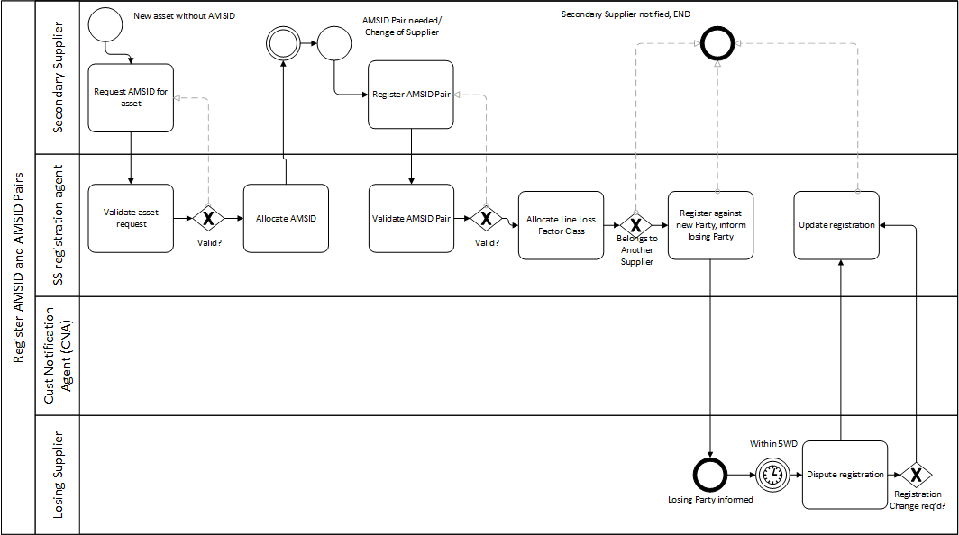

Ref. no | Business Requirement
P379-BR5 Request AMSID for new assets
P379-BR5 | P379-BR5.1 Secondary Supplier must be able to request AMSID from Secondary Supply registration agent.  Requirement Description  [proposed & alternative] For new Asset Metering Systems that a Secondary Supplier wishes to use to provide additional supply, the Secondary Supplier must request a unique AMSID from the Secondary Supply registration agent.  The Secondary Supplier could list more than one meters against one AMSID as long as the Metering Systems measure the Metered Volumes for Assets located on the same site ‘below’ the same Boundary Point(s).  For avoidance of doubt, the use of asset metering is a commercial choice. The Secondary Supplier will decide what metering solution best suits each individual site.  Re-use of P375-BR3
P379-BR5.2 Secondary Supplier must provide the following information when submitting AMSID request.

Requirement Description

[proposed & alternative] When requesting a new AMSID, the Secondary Supplier must provide the following information:

GSP Group Id
All Associated Supplier Boundary Point Import MSID(s)

The Secondary Supplier will have to specify how many Import and Export AMSIDs the
Secondary Supply registration agent needs to allocate for a given Asset.

Re-use of P375-BR4
P379-BR5.3 Secondary Supply registration agent must validate AMSID request.

Requirement Description

[proposed & alternative] Within 1WD of receiving a request for a new AMSID(s), the Secondary Supply registration agent must check that it is complete and valid. The AMSID registration Secondary Supply registration agent may liaise with the Secondary Supplier that submitted the request to seek additional information, corrections or a resubmission of the request.
If, following any liaison between AMSID registration Secondary Supply registration agent and the Secondary Supplier, Secondary Supply registration agent Secondary Supply registration agent believes the request to be invalid, then Secondary Supply registration agent will reject the request and notify the Secondary Supplier by electronic means with a rationale.

The Secondary Supply registration agent should use information contained within its own database or in external databases (e.g. Secondary Supply registration agent may use, but is not limited to, ECOES, Ofgem’s Public Register and Companies House) to check the completeness, accuracy and validity of a request.

The Secondary Supply registration agent could check:
Whether Boundary Point MSID(s) in the request is ‘live’ (not disconnected).
Line Loss Factor Class (LLFC) of the Boundary Point MSID(s).
Organisation submitting the request is a BSC Party (VLP).

Please note that Secondary Supply registration agent should not be limited to the above checks and could deploy a different check where appropriate.

Re-use of P375-BR9
P379-BR5.4 Secondary Supply registration agent must allocate AMSIDs.

Requirement Description
[proposed & alternative] Where the validation was successful for a given Asset Metering System, then the Secondary Supply registration agent must allocate AMSID against that/those Asset Metering System(s) and pre-register AMSID Pair(s) within the same Working Day.

Re-use of P375-BR10
P379-BR5.5 Secondary Supply registration agent must notify the Secondary Supplier of AMSID application outcome within 1WD.

[proposed & alternative]

Re-use of P375-BR11
P379-BR5.6 The AMSIDs created by Secondary Supply registration agent need to be unique, i.e. they cannot be a duplication of standard MSIDs nor the Pseudo Metering Points.

[proposed & alternative]

Re-use of P375-BR13
P379-BR6 Register AMSID Pairs for assets
P379-BR6 | P379-BR6.1 Secondary Supplier must register AMSID Pair(s) with the Secondary Supply registration agent.  Requirement Description  [proposed & alternative]  When completing a registration of an AMSID Pair, the Secondary Supplier who will fulfil the role of ‘Asset Metering System Registrant’ must provide the following information at least 5 WD prior to the Effective from Date of the AMSID Pair:  Import/Export AMSID  Data Collector Id (MPID) for Import/Export AMSID  HHDC Effective from Date  HHDC Effective to Date  Meter Operator Id (MPID) for Import/Export AMSID (where applicable)  MOA Effective from Date (where applicable)  MOA Effective to Date (where applicable)  Associated Supplier Boundary Point Import MSID(s)  The connection voltage at the Asset Meter System  The connection voltage at the Supplier Boundary Point MSID  Balancing delivery capacity of the asset in kW  Asset type (e.g. diesel generator, battery storage unit, Electric Vehicle charging unit)  AMS make and model  AMS IEC standard  Asset Meter Serial Number  MOA alternative used  BM Unit  For avoidance of doubt, when registering existing AMSIDs into AMSID Pair, Secondary Suppliers should use a defined flow format published on ELEXON website and submit to Secondary Supply registration agent (the data flow will be defined in the applicable Code Subsidiary Document).  Re-use of P375-BR5
P379-BR6.2 AMSID Pairs must be associated with at least 1 import Boundary Point MSID.

Requirement Description

[proposed & alternative] Secondary Suppliers must ensure that an AMSID Pair is associated with a Boundary Point MSID i.e. the AMSID Pair is for a site behind the Boundary Point site. If it is not associated with a Boundary Point MSID, the Secondary Supplier must register this as an MSID Pair as per requirement P379-BR6.3 below.
P379-BR6.3 Secondary Suppliers must register all affected Boundary Point MSID Pair(s) with Secondary Supply registration agent when registering AMSID Pairs.

Requirement Description
[proposed & alternative]

This must be done concurrently to the AMSID Pair registration. For avoidance of doubt, AMSID Pair will not be fully registered if the associated Boundary Point MSID Pairs are not registered in the Secondary Supply registration agent.
To register the MSID Pair the VLP will have provide the following details:
The Secondary BM Unit Id
The GSP Group Id;
The MSID of the Import Metering System
The MSID of the Export Metering System (where applicable)
The MSID Pair Effective From Settlement Date
The MSID Pair Effective To Settlement Date
A Import Metering System Customer Consent Flag
A Import Metering System Customer Consent Flag Effective From Settlement Date
A Import Metering System Customer Consent Flag Effective To Settlement Date
A Export Metering System Customer Consent Flag
A Export Metering System Customer Consent Flag Effective From Settlement Date
A Export Metering System Customer Consent Flag Effective To Settlement Date

For the avoidance of doubt, where there are more than one Secondary Supplier operating Assets located ‘behind’ a given Boundary Point Metering System, each Secondary Supplier will have to register the Boundary Point MSID Pair against its AMSID Pair.

Re-use of P375-BR19
P379-BR6.4 Secondary Supply registration agent must validate AMSID Pair registration.

Requirement Description
[proposed & alternative] Within 1 WD of receiving all required AMSID Pair registration details, the Secondary Supply registration agent must check that the registration is complete and valid. The Secondary Supply registration agent may liaise with the Secondary Supplier that submitted the registration to seek additional information, corrections or a resubmission of the registration.

The completeness of the registration will be validated against the defined flow format published in the Code Subsidiary Document on ELEXON website. For avoidance of doubt, if, following any liaison between Secondary Supply registration agent and the Secondary Supplier, any information is missing, Secondary Supply registration agent will reject the registration and notify the Secondary Supplier by email or other electronic means of its reason.

If, following any liaison between Secondary Supply registration agent and the VLP, Secondary Supply registration agent believes the registration to be invalid, then SVAA will reject the registration and notify the VLP by email or other electronic means of its reason.

Secondary Supply registration agent should use information contained within its own database or in external databases (e.g. Secondary Supply registration agent may use, but is not limited to, ECOES, Ofgem’s Public Register and Companies House) to check the completeness, accuracy and validity of a registration.

The Secondary Supply registration agent could check:
Whether AMSID in the request exists.

That the Boundary Point MSID(s) in the registration is ‘live’ (not disconnected).
That the Boundary Point MSID(s) are already registered within a SBMU.
Half Hourly Data Collector is BSC Qualified.
Meter Operator Agent is BSC Qualified or meets the criteria of ‘BSC MOA alternative’.
AMSID is already registered against a different VLP.

Please note that Secondary Supply registration agent should not be limited to the above checks and could deploy a different check where appropriate.

Re-use of P375-BR20
P379-BR6.5 Secondary Supply registration agent must notify Secondary Supplier(s) upon reviewing AMSID Pair registration.

Requirement Description
[proposed & alternative]

After reviewing AMSID Pair registration, within the same Working Day, the Secondary Supply registration agent will issue a notification to the Secondary Supplier.
Where the registration was successful, Secondary Supply registration agent will confirm that AMSID Pair is now registered and can be used for provision of Balancing Services as of ‘Effective from Date’.
At the same time, Secondary Supply registration agent will check whether Boundary Point MSID Pairs linked to that AMSID Pair are registered in ‘SVA Metering System Register’ for provision of Balancing Services in line with P344 (i.e. Secondary Supply registration agent will check whether another VLP uses a given Boundary Point MSID Pair for provision of Balancing Services). Where the MSID Pair is used for provision of Balancing Service, the Secondary Supply registration agent will issue a notification to the VLP who registered that MSID Pair.

Where the registration was unsuccessful, Secondary Supply registration agent will provide the rationale in the notification issued to the Secondary Supplier.

Re-use of P375-BR21
P379-BR6.6 Secondary Supply registration agent must allocate Line Loss Factor Class against AMSID.

Requirement Description
[proposed & alternative]
At the same time as registering AMSID Pair within the Asset Meter Central Register, the Secondary Supply registration agent must allocate Line Loss Factor Cla the ss against an each Asset Meter System Id. The Secondary Supply registration agent will allocate the LLFC based on the voltage level of the AMSID connection.

Re-use of P375-BR22
P379-BR6.7 Secondary Suppliers must notify Secondary Supply registration agent upon the change of Secondary Supplier for an Asset.

Requirement Description
[proposed & alternative]

Secondary Suppliers must notify Secondary Supply registration agent upon change of ownership of an Asset Metering System at least 5WD prior to the Effective from Date of the AMSID Pair.
SVAA should perform the same validation as for a registration of a new AMSID Pair (see P375-BR20).
Where the validation is successful, Secondary Supply registration agent will amend its records (to indicate the change of Asset Metering Registrant) and the ensure that the ‘SVA Metering System Register is updated if applicable (to indicate that the Pair should be aggregated under another Secondary BM Unit)’.

Re-use of P375-BR23
P379-BR6.8 A new Supplier registers an existing AMSID Pair.

Requirement Description

If a new Supplier registers an existing AMSID Pair the Secondary Supply registration agent must action the registration and inform the losing Supplier that the AMSID Pair is no longer registered to that Supplier’s BMU within the same working day.

Upon being informed of a loss of registration from a Primary BM Unit it is the responsibility of the Supplier of that Primary BM Unit to ensure that the AMSID volumes are no longer submitted to the Calculation Entity.
P379 -BR6.9 The SVAA Balancing Services Register is kept up to date
If Secondary Supply registration agent is not SVAA, it must provide update to ‘SVA Metering System Register’.

Requirement Description
Where the validation was successful for a given AMSID Pair, then the Secondary Supply registration agent must inform the SVAA of changes impacting on the ‘SVA Metering System Register’ made by the Secondary Supplier, (i.e. addition of Boundary Point MSID Pair(s)) linked to that AMSID Pair (see P375-BR19).

Re-use of P375-BR28
P379-BR6.10 A Supplier losing an AMSID Pair may dispute the erroneous transfer within 5WD

Requirement Description
If a Secondary Supplier believes that one of their AMSID Pairs has been transferred to another Supplier erroneously, they must object within 5WD. The process should follow MRA Procedure for Resolution of Erroneous Transfers (MAP10) if registration agent is MPAS, BSCP602 section 2.3 if registration agent is SVAA and a similar process if registration agent is other.
P379-BR6.11 A Secondary Supplier must be able to de-register an AMSID.

Requirement Description
Where a Secondary Supplier wishes to stop using an AMSID and effectively de-register the AMSID Pair, the Secondary Supplier must use a defined data flow published in the Code Subsidiary Document on ELEXON website and submit it to the Secondary Supply registration agent.

Appoint agents / use of agents
Ref. no | Business Requirement
P379-BR7 Appoint / instruct agents for new AMSID Pairs
P379-BR7 | P379-BR7.1 MOA must install and maintain Code of Practice (COP) compliant Asset Metering System.  Requirement Description  The Secondary Supplier must provide its MOA with AMSIDs to be used for a given Asset. The MOA will install the Asset Metering System(s) on the network as agreed with the Secondary Supplier. Asset Metering System must conform to the COP11 requirements. Following meter installation, MOA should send information about the meter (AMS make and model, AMS IEC standard, Asset Meter Serial Number) to the Secondary Supplier.  If an AMSID exists for the site, the MOA must inform the Secondary Supplier as per P379-BR7.5  Re-use of P375-BR6
P379-BR7.2 Secondary Supplier appoints a Half Hourly Data Collector (HHDC) to provide metered volumes for the AMSID Pair, if not appointed already.

Requirement Description
[proposed] & [alternative] The Secondary Supplier appoints a Half Hourly Data Collector (HHDC) to provide metered volumes for each AMSID within the AMSID Pair, if not appointed already, using the D0155 flow. The process must mirror existing appointment process performed by Suppliers in line with BSCP502 Section 3.2.

Re-use of P375-BR7
P379-BR7.3 Secondary Suppliers must appoint MOA or MOA Alternative.

Requirement Description

Secondary Suppliers must appoint a Meter Operator Agent or Meter Operator Agent Alternative for each AMSID within AMSID Pair. The process must mirror existing appointment performed by Suppliers in line with BSCP514 Section 5.2.

Re-use of P375-BR8
P379-BR7.4 VLPs must use an asset’s AMSID Pair if they are providing Balancing Services from an asset which already has a registered AMSID.

Requirement Description
[proposed & alternative]

If a VLP does not use an asset’s AMSID, VLP Delivered volumes will be shared between all Suppliers (except a Secondary Supplier using an AMSID Pair) on a site in proportion to the volumes each Supplier is responsible for. To enable this to happen, the VLP’s

New for P379.
P379-BR7.5 MOA must inform it’s Party that asset already has asset metering

Requirement Description
[proposed & alternative]

This supports requirement P379-BR7.4, enabling each Party to use existing AMSID Pairs.

P379-BR7.5.1 A Secondary Supplier’s MOA must inform the Secondary Supplier that an asset has an AMSID Pair.

P379-BR7.5.2 A VLP’s MOA must inform the VLP that an asset has an AMSID Pair.

Instruct/obtain volumes

Ref. no | Business Requirement
P379-BR8 | P379-BR8.1 SVAA instructs Primary Supplier’s HHDA to provide Boundary Point metered volumes.  Requirement description  [proposed only] For all Boundary Point MSIDs related to asset based Secondary Supply, the SVAA will instruct the Primary Supplier’s HHDA to provide metered volumes for the Boundary Point MSIDs associated with the Secondary Supplier’s registered AMSID upon receipt of the ICN. The SVAA will instruct the Primary Supplier’s HHDA via the D0385 data flow.
P379-BR8.2 Primary Supplier’s HHDA accepts or rejects instruction

Requirement description

[proposed only] The Primary Supplier’s HHDA accepts or rejects instruction to provide metered volumes for the Boundary Point MSID using the existing D0355 / D0366 flows as applicable.

See Section 3.4.10 for exception handling
P379-BR8.3 Secondary Supplier notifies calculation entity which HHDC (Secondary Supplier or VLP appointed) will provide metered volumes for the AMSID Pair.

Requirement Description
[proposed] Upon successful registration of Secondary Supply, for all AMSIDs in the ICN, the Secondary Supplier must notify SVAA which Secondary Supplier HHDC will provide metered volumes for the AMSID for which duration.

[alternative] Upon successful registration of Secondary Supply, for all AMSIDs in the ICN, the Secondary Supplier must notify the Primary Supplier’s HHDC which Secondary Supplier HHDC will provide metered volumes for the AMSID for which duration.

This will be a d-flow notification with the following data items:
Secondary Supplier
Secondary Supplier BMU
AMSID Pair
HHDC
Effective From Date
Effective To Date
P379-BR8.5 Secondary Supplier instructs its appointed Half Hourly Data Collector (HHDC) to provide metered volumes for the AMSID

Requirement Description
Upon successful registration of Secondary Supply, for all AMSIDs in the ICN, the Secondary Supplier must instruct the Secondary Supplier’s HHDC to provide metered volumes for the duration of the contract using the D0036.
P379-BR8.6 Secondary Supplier informs Primary Supplier HHDC of who its HHDA is (for existing DC DA process)

Requirement Description
[alternative] Upon successful registration of Secondary Supply, the Secondary Supplier informs the Primary Supplier’s HHDC of who the Secondary Supplier’s HHDA is.

Provide/receive volumes

Ref. no | Business Requirement
P379-BR9 | P379-BR9.1 The Primary Supplier’s HHDA provides metered volumes for all associated Boundary Points within [1WD] of the applicable Settlement Period  Requirement description  [proposed only] For all MSID Pairs involved in Secondary Supply, the Primary Supplier’s HHDA must provide metered volumes for the Boundary Point to the SVAA via the D0385 data flow.
P379-BR9.2 Secondary Supplier’s HHDC provides metered volumes for each AMSID Pair to the calculation entity within [1WD] of the applicable Settlement Period.

Requirement description

[proposed] The Secondary Supplier’s HHDC must provide metered volumes for each AMSID Pair related to the applicable Boundary Point MSID to the SVAA within [1 WD] of the applicable Settlement Period (D0036 or similar).

[alternative] The Secondary Supplier’s HHDC must provide metered volumes for each AMSID related to the applicable Boundary Point MSID to the Primary Supplier’s HHDC within [1 WD] of the applicable Settlement Period (D0036 or similar).
P379-BR9.3 CNA provides updated CVNs for each Secondary Supplier at each Boundary Point to the calculation entity 1 hour before start of applicable Settlement Period.

Requirement description

[proposed] For fixed or percentage based Secondary Supply, the CNA will provide the latest CVN for the duration of Secondary Supply to the SVAA [1 hour] ahead of Gate Closure.

[alternative] For fixed or percentage based Secondary Supply, the CNA will provide the latest CVN for the duration of Secondary Supply to the Primary Supplier’s HHDC [1 hour] ahead of Gate Closure.
P379-BR9.4 Calculation entity rejects conflicting notifications

Requirement description

The Calculation Entity must reject any notifications which create a conflict between multiple Secondary Suppliers

P379-BR9.4.1 This means that where a CNA submits multiple notifications which add to more than 100%, the calculation entity must reject the notification which results in the total percentage exceeding 100%.

P379-BR9.4.2 Where a CNA submits fixed volumes from more than one Secondary Suppliers and those volumes exceed the MSID metered volume, the calculation entity must assign volumes to each Secondary Supplier in the order that the CVNs were received until there is no more volume to allocate.
P379-BR9.5 The calculation entity provides metered volumes and/or notifications to other Suppliers upon receipt.

Requirement description

[proposed] SVAA will provide metered volumes to the Primary Supplier or other Secondary Suppliers at the MSID Pair (or AMSID Pair) upon receipt.

[alternative] The Primary Supplier’s HHDC will provide metered volumes to the Primary Supplier or other Secondary Suppliers at the MSID Pair (or AMSID Pair) upon receipt.

The calculation entity will not provide volumes to Suppliers if that Supplier’s supply position is not impacted by the volume.

Split Boundary Point meter readings
This section contains requirements to calculation the share of each Supplier. The map below provides a brief overview of the calculation process.
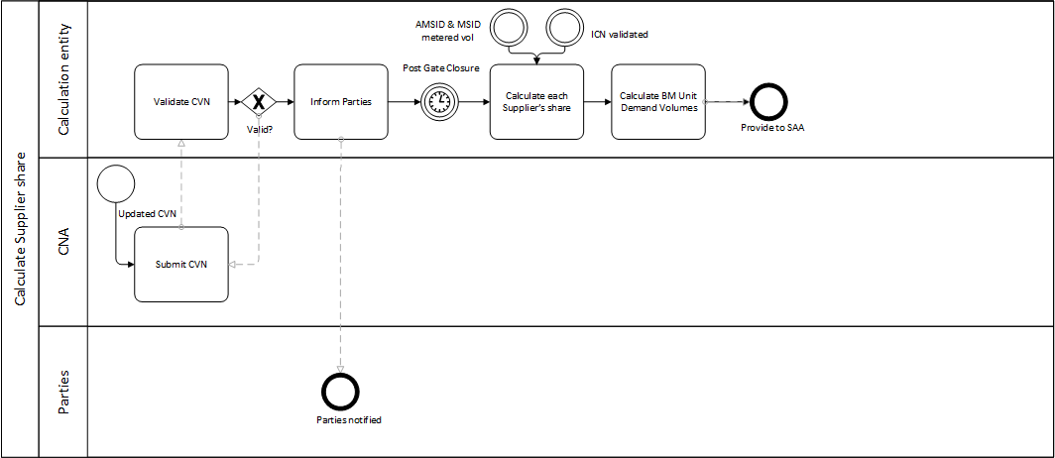
Ref. no | Business Requirement
P379-BR10 | P379-BR10.1 Split the Boundary Point MSID meter reading between Suppliers.  [proposed] The SVAA splits the Boundary Point MSID Pair meter reading between Suppliers.  [alternative] The Primary Supplier’s HHDC splits the Boundary Point MSID meter reading between Suppliers.  Requirement Description  Where there are multiple Suppliers behind an AMSID, the AMSID Pair volume is split.  AMSID Pair volume takes priority with the remaining volume, if any, split as per the submitted CVN.  Primary Supplier’s share / Boundary point MSID reading: VMMC (provided by the HHDA)  Secondary Supplier’s share / Asset Meter Reading: SMMC (provided by the HHDC)
BR10.1a | P379-BR10.1a Calculate the Primary Supplier’s share of the Boundary Point MSID  [proposed & alternative]  MSID Pair volumes are represented as VMMC and AMSID Pair volumes are represented as SMMC  If CVN relates to fixed volume and ∑SMMC + CVN ≤ VMMMC then VMMC = VMMMC-∑SMMC (behind the Meter AMSID Pairs of Secondary Supplier)) – fixed CVN  If CVN relates to fixed volume and ∑SMMC + CVN > VMMC then VMMC = ∑SMMC  If CVN relates to a percentage volume then VMMC = (VMMMC-∑SMMC) * (1-%CVN)  BR10.1a – step 1 (sum AMSID volumes)  If there are one or more AMSIDs associated with the Boundary Point MSID and registered by Secondary Supplier(s), sum the metered volumes of these AMSIDs: ∑^{K}_{J} SMMC_{ZaKJj}  BR10.1a – step 2 (subtract from BP MSID volume)  Subtract the sum in step 1 from the Boundary Point MSID volume: VMMC_{ZaKJj (MSID)} - ∑^{K}_{J} SMMC_{ZaKJj (AMSID)}  BR9.1a – step 3 (apply fixed CVN)  If CVNs have been submitted and are of the type fixed: for each fixed CVN, subtract the fixed CVN from the value in step 2. The Primary Supplier’s metered volume must not be less than zero.  BR9.1a – step 4 (apply % CVN)  If CVNs have been submitted and are of the type %: for each % CVN:  - Subtract the % of the CVN from 1  - Multiply the value in step 2 by the value in step 4 (i) and add it to the original value from step 2  The above calculation will need to take into consideration AMSID Pair volumes from a VLP if there is a VLP operating behind the Boundary Point Meter, either using the same AMSID Pair as the Secondary Supplier, or via a separate AMSID Pair. See section 3.4.10 ‘Calculation scenarios’.  Where there are multiple Suppliers behind an AMSID, the AMSID Pair volume becomes VMMC and the asset behind the AMSID Pair becomes the SMMC. The AMSID volumes are determined separately, and do not affect the splitting of the MSID volumes.
BR10.1b | P379-BR10.1b Calculate the Secondary Supplier’s share of the Boundary Point MSID  Requirement Description  [proposed & alternative]  MSID Pair volumes are represented as VMMC and AMSID Pair volumes are represented as SMMC  If CVN relates to fixed volume and ∑SMMC + CVN ≤ VMMMC then SMMC = ∑SMMC (behind the meter assets for a Secondary Supplier) + fixed CVN  If CVN related to fixed volume and ∑SMMC + CVN > VMMMC then SMMC = VMMMC  If CVN relates to a percentage volume then SMMC = ∑SMMC (behind the meter assets for a Secondary Supplier) + ∑SMMC (behind the meter assets for a Secondary Supplier) * %CVN  SMMC = ∑SMMC (behind the meter assets for a Secondary Supplier) + fixed CVN or ∑SMMC * %CVN  Note that following a meter splitting calculation where a %CVN is applied, the result must not exceed ASMID Pair or MSID Pair metered volume.  BR10.1a – step 1 (sum AMSID volumes)  If there are one or more AMSIDs associated with the Boundary Point MSID and registered by Secondary Supplier(s), sum the metered volumes of these AMSIDs: ∑^{K}_{J} SMMC_{ZaKJj (AMSID)}  BR10.1b – step 2 (apply fixed CVN)  If CVNs have been submitted and are of the type fixed: for each fixed CVN, add the fixed CVN from the value in step 2. The Secondary Supplier’s metered volume must not be greater than the Boundary Point MSID’s metered volume.  BR10.1b – step 3 (apply % CVN)  If CVNs have been submitted and are of the type %: for each %CVN, multiply the value in BR10.1a – step 1 by the % CVN and add it to the original value from step 1.  The above calculation will need to take into consideration AMSID Pair volumes from a VLP if there is a VLP operating behind the Boundary Point Meter, either using the same AMSID Pair as the Secondary Supplier, or via a separate AMSID Pair. See section 3.4.10 ‘Calculation scenarios’.  Where there are multiple Suppliers behind an AMSID, the AMSID Pair volume becomes VMMC and the asset behind the AMSID Pair becomes the SMMC.
 | P379-BR10.2 The sum of the assigned Secondary Supply volumes must not exceed the Boundary Point MSID Pair (or AMSID Pair if this applies to behind the asset meter) metered volume once any asset volumes have been removed.
P379-BR10.3 The calculation entity determines the CCC ID for the SMMC post-split

Requirement Description

Metered Data for AMSID Pairs submitted by HHDC will not have been allocated to a CCC. The calculation entity will need to allocate the correct CCC ID, based on:
Whether the Asset MSID is Import or Export
Whether the Asset Meter reading is Actual or Estimated

[proposed] SVAA will allocate the CCC ID to the metered data for AMSID Pairs
[alternative] The Primary Supplier’s HHDC will allocate the CCC ID to the metered data for AMSID Pairs

Re-use of P375-BR31
CCC IDs can be found in BSC Section X-2
P379-BR10.4 The calculation entity must categorise Metered Volume data sent by HHDC into BM Unit’s Metering System Metered Consumption (ABMMMC).

Requirement Description

For each AMSID, SVAA will use the Metered Volume data provided by HHDC, as well as LLFC and CCC Id to group the Metered Volume data into Secondary BM Unit’s Metering System Metered Consumption.

[proposed] SVAA will categorise the metered volume data to create ABMMMC
[alternative] The Primary Supplier’s HHDC will categorise the metered volume data to create ABMMMC
P379-BR10.5 The calculation entity must separate the ABMMC value into losses (BMMCL) and non-losses (BMMC)

Requirement Description

For each AMSID, SVAA will use the Metered Volume data provided by HHDC, as well as LLFC and CCC Id to group the Metered Volume data into Secondary BM Unit’s Metering System Metered Consumption.

[proposed] SVAA will separate the ABMMC value into losses (BMMCL) and non-losses (BMMC)
[alternative] The Primary Supplier’s HHDC will separate the ABMMC value into losses (BMMCL) and non-losses (BMMC) and provide this to SVAA within XWD of receiving the meter split.

BMMC and BMMCL will feed into the standard CLOSS and C calculation carried out by SVAA that aggregates the losses and non-losses by BMU and Settlement Period.
P379-BR10.6 The calculation entity will notify Parties of their share of meter split within 1WD of completion of the meter split calculation.

Requirement Description

[proposed] The SVAA will notify the Primary and Secondary Supplier(s) of their share of the meter split within 1WD (relevant output of BR9.1).

[alternative] The Primary Supplier’s HHDC will notify the Primary and Secondary Supplier(s) of their share of the meter split within 1WD (relevant output of BR9.1).
P379-BR10.6 SVAA will calculate the share for each Supplier of Delivered Volumes in relation to Balancing Services provided by VLPs behind the Boundary Point.

Requirement Description

[proposed] To ensure each Supplier’s imbalance position is not affected as a result of Delivered Volumes submitted by VLPs, the SVAA calculates each Supplier’s proportion of the Delivered Volumes. This could be for MSID Pairs that are participating in Balancing Services (introduced by TERRE) or AMSID Pairs that are participating in Balancing Services (introduced by P375).

[alternative] The Primary Supplier’s HHDC must provide to SVAA disaggregated (MSID Pair and AMSID Pair) volumes by Supplier for each MSID Pair where a Secondary Supplier and VLP are operating.

Depending on what is happening behind the Boundary Point, this calculation will need to be updated as per the decision table provided under section 3.4.6 ‘Calculation Scenarios’.

Calculation scenarios
The following decision table shows the calculation approach to splitting metered volumes depending on the scenario. The scenarios take into consideration P344 and P375 solutions.
If there is a Secondary Supplier operating behind the Boundary Point Meter, and its volumes are not isolated by an AMSID, the Secondary Supplier will be allocated a share of any Delivered Volumes relating to Balancing Services at the Boundary Point meter, provided by a VLP. Note that Delivered volumes are allocated to Suppliers by the SVAA.

Secondary Supply? | SS AMSID? | CVN? | VLP? | VLP AMSID? | PS calc approach | AMSID SS calc approach | CVN SS calc approach
Yes | No | No | No | No | No change | n/a
Yes | No | Yes – fixed | No | No | MSID - CVN | n/a | CVN at MSID
Yes | No | Yes – fixed | Yes | No | MSID – CVN  VLP Delivered Volumes at BP are shared proportionally amongst Suppliers | n/a | CVN at MSID  VLP Delivered Volumes at BP are shared proportionally amongst Suppliers
Yes | No | Yes – fixed | Yes | Yes | MSID – AMSID - CVN | n/a | CVN at MSID
Yes | No | Yes - % | No | No | MSID * (1-CVN) | n/a | MSID * CVN
Yes | No | Yes - % | Yes | No | MSID * (1-CVN)  VLP Delivered Volumes at BP are shared amongst Suppliers using % CVN | n/a | MSID * CVN  VLP Delivered Volumes at BP are shared amongst Suppliers using % CVN
Yes | No | Yes - % | Yes | Yes | MSID * (1-CVN)  VLP Delivered Volumes at BP are shared amongst Suppliers using % CVN | n/a | MSID * CVN  VLP Delivered Volumes at BP are shared amongst Suppliers using % CVN
Yes | Yes | No | No | No | MSID – AMSID | AMSID | n/a
Yes | Yes | No | Yes | No | MSID – AMSID  VLP Delivered Volumes at BP are shared proportionally amongst Suppliers | AMSID  VLP Delivered Volumes at BP are shared proportionally amongst Suppliers | n/a
Yes | Yes | No | Yes | Yes – same as SS | MSID – AMSID  VLP Delivered Volumes at AMSID go to SS | AMSID | n/a
Yes | Yes | No | Yes | Yes – diff to SS | MSID – SS AMSID – VLP AMSID  VLP Delivered Volumes at AMSID go to PS | AMSID | n/a
Yes | Yes | Yes - fixed | No | No | MSID – AMSID – CVN | AMSID | CVN
Yes | Yes | Yes – fixed | Yes | No | MSID – AMSID – CVN  VLP Delivered Volumes at BP are shared proportionally amongst PS and CVN SS | AMSID | CVN  VLP Delivered Volumes at BP are shared proportionally amongst PS and CVN SS
Yes | Yes | Yes – fixed | Yes | Yes – same as SS | MSID – SS AMSID – VLP AMSID - CVN  VLP Delivered Volumes at AMSID go to SS | AMSID  VLP Delivered Volumes at AMSID go to SS | CVN
Yes | Yes | Yes – fixed | Yes | Yes – diff to SS | MSID – SS AMSID – VLP AMSID - CVN  VLP Delivered Volumes at AMSID go to PS | AMSID | CVN  VLP Delivered Volumes at AMSID go to PS
Yes | Yes | Yes - % | No | No | MSID * (1-CVN) | AMSID | MSID * CVN
Yes | Yes | Yes - % | Yes | Yes – same as SS | MSID – SS AMSID – (remaining MSID * (1-CVN))  VLP Delivered Volumes at AMSID go to SS | AMSID  VLP Delivered Volumes at AMSID go to SS | MSID * CVN
Yes | Yes | Yes - % | Yes | Yes – diff to SS | MSID – SS AMSID – VLP AMSID - (remaining MSID * (1-CVN))  VLP Delivered Volumes at AMSID go to PS | AMSID | Remaining MSID * CVN

The following flow charts following the table illustrate how the P379 meter splitting calculations fit into the calculations for existing/approved changes (e.g. P344) and those required by changes in flight (P375). There is a flowchart for the proposed and alternative options.

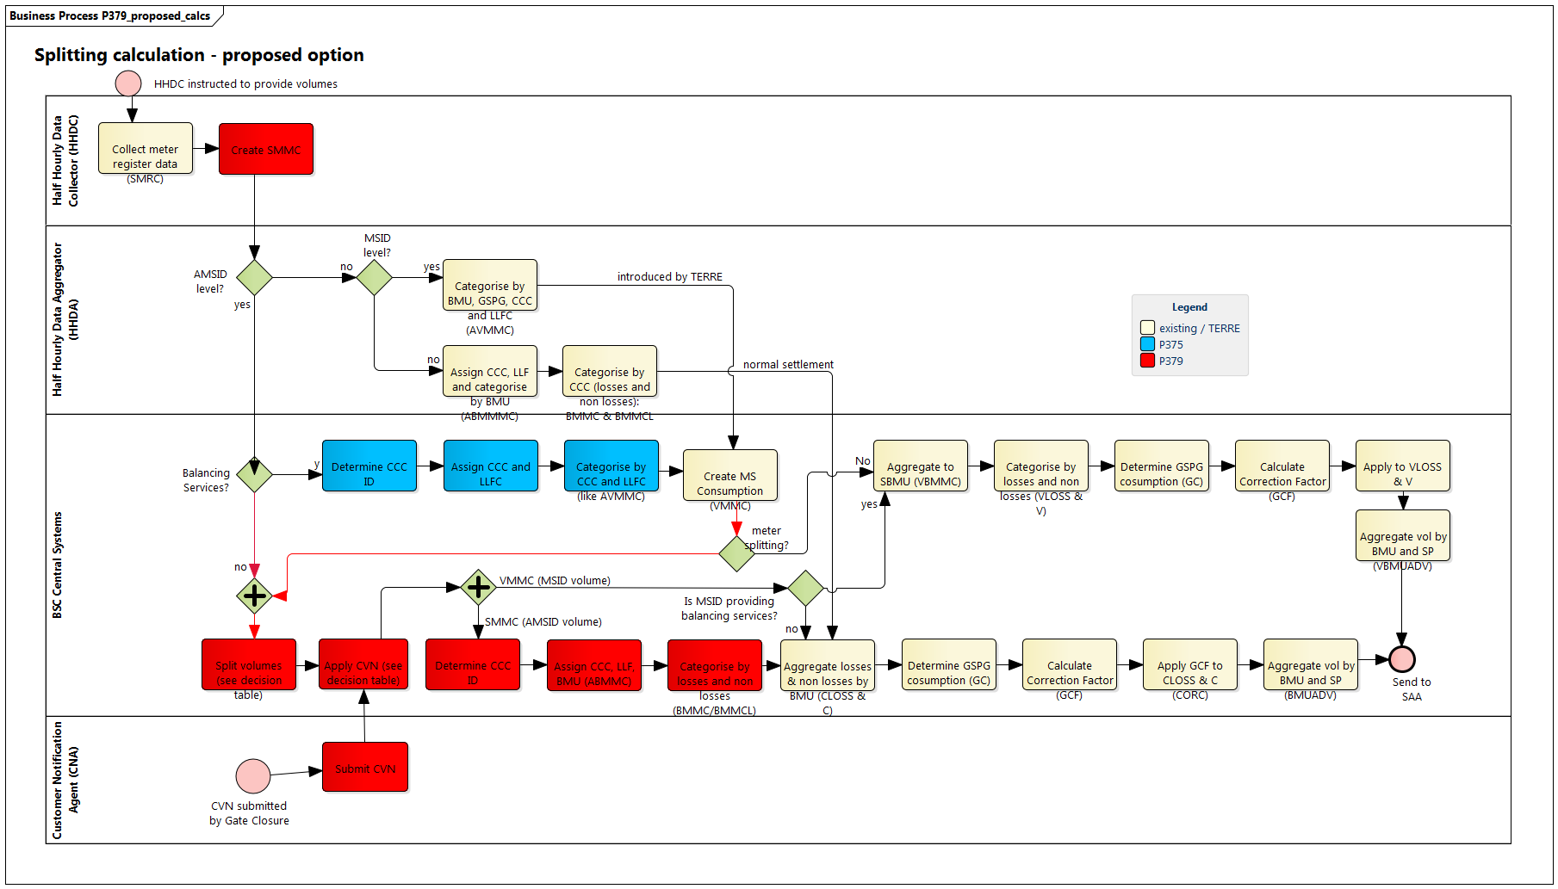

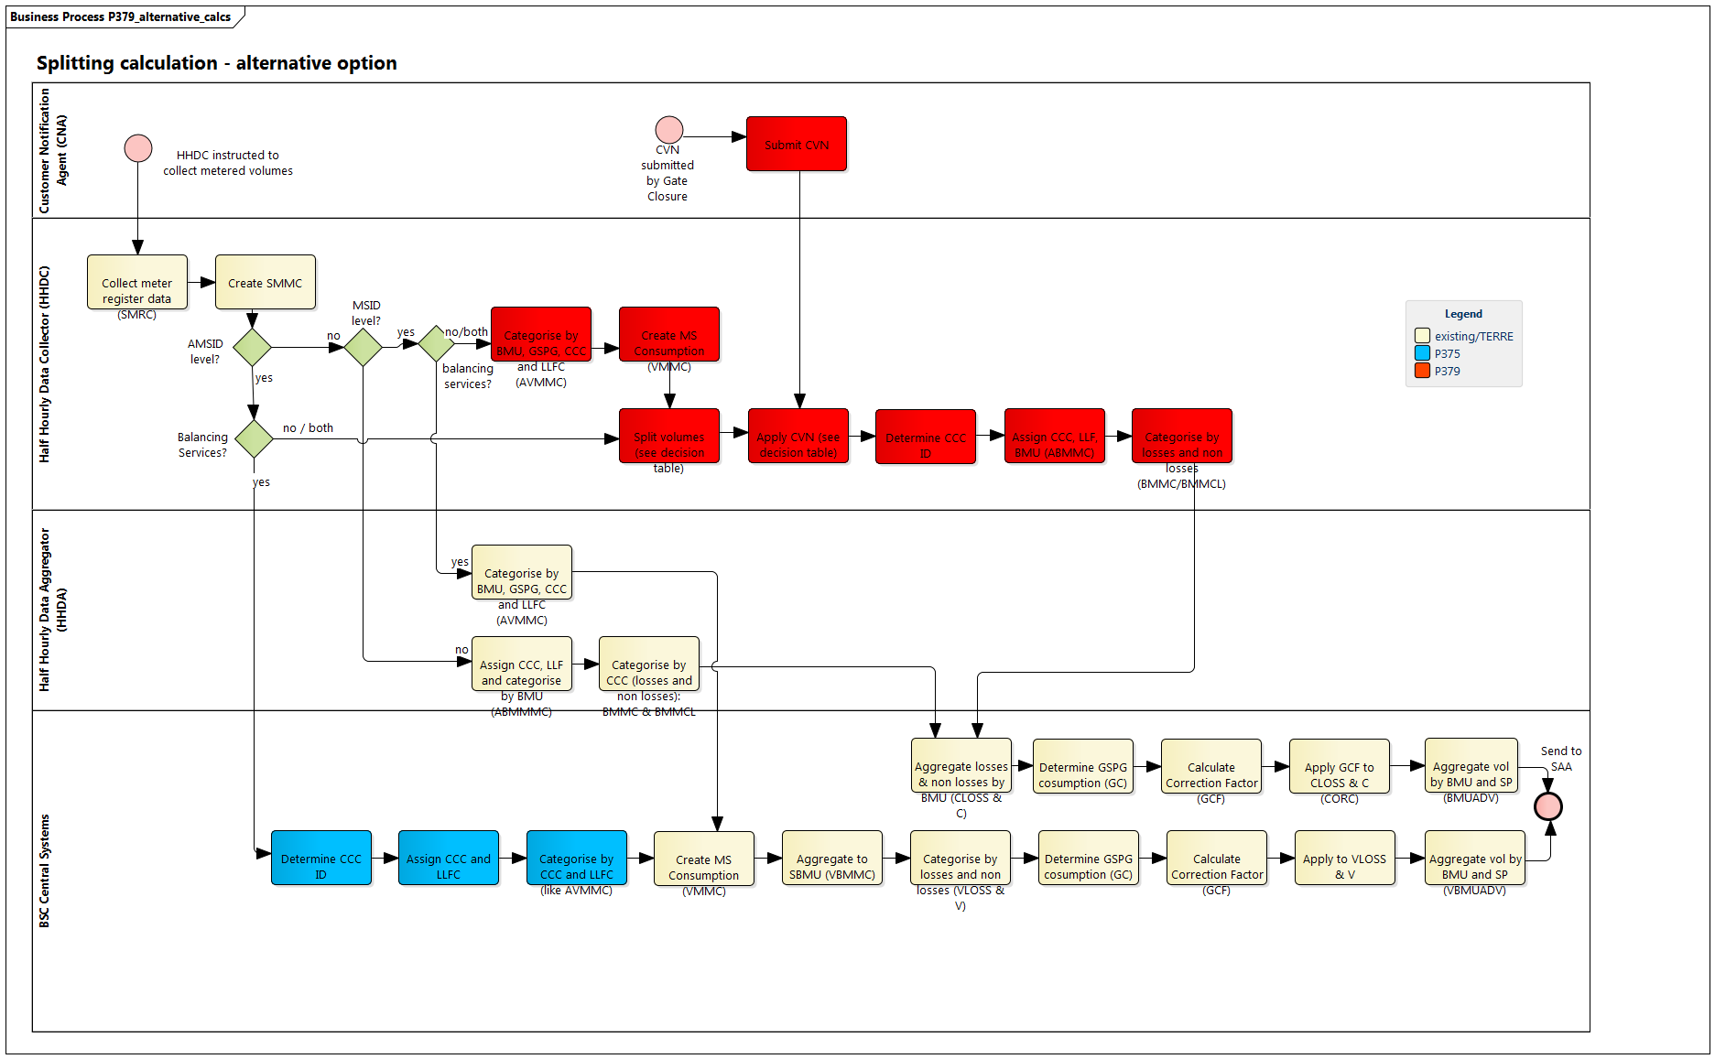

Allocate volumes

Ref. no | Business Requirement
P379-BR11 | P379-BR11.1 SVAA uses the categorised losses (BMMCL) and non-losses (BMMC) metered volumes to calculate each Supplier’s BM Unit Allocated Demand Volume [as per the existing SVA Volume Allocation Run timescales]  Existing process

Reporting

Ref. no | Business Requirement
P379-BR12 | P379-BR12.1 Report on percentage of Secondary Supply  Requirement Description  [proposed] The BSC Central Systems must be able to report on  - number of MSID Pairs and AMSID Pairs used for the purposes of Secondary Supply each month  - percentage of all meter volumes attributable to Secondary Supply

Performance Assurance
Ref. no | Business Requirement
P379-BR13 | Performance Assurance
P379-BR13.1 Once AMSID Pair becomes live and starts operating, SVAA could (as required) review (from time to time) the asset registration evidence as a part of its assurance activities.

[proposed] & [alternative]

Re-use of P375-BR50
P379-BR13.2 The PAF must ensure that an asset doesn’t have more than one set of metering

Requirement Description
[proposed] & [alternative]: The PAF must check that Parties are not creating multiple AMSID Pairs for an asset. See requirements P379-BR7.4 and P379-BR7.5.
Performance Assurance Framework (PAF)
P379-BR13.5 Suppliers should be able to raise a Trading Dispute against Asset Metering System Metered Volumes.

Requirement Description
[proposed] & [alternative]: A Supplier must be able to dispute erroneous data, for example:
- Incorrect association between BM Units and AMSID or MSID Pairs
- Incorrect registration details entered
- Incorrect splitting of metered volumes

Re-use of P375-BR54
P379-BR13.7 Secondary Suppliers must be subject to the same performance assurance measures as Primary Suppliers

Performance assurance measures won’t make any distinction between a Supplier providing Secondary Supply or any other Supply volumes.

Change of Supplier / Agent / Occupier
Ref. no | Business Requirement
P379-BR14 | P379-BR14.1 Each Primary Supplier ensures metered volumes for MSID Pairs and AMSID Pairs (if there are assets behind the AMSID) are provided as expected.  Requirement Description  [proposed] & [alternative]: The Primary Supplier must ensure that metered volumes are being provided for the Boundary Point MSID(s) for the duration that it has been instructed to provide metered volumes for.  At minimum, the following scenarios must be catered for  - In the case of any change of Supplier, the Primary Supplier must ensure that the BSC Central Systems are informed as per existing processes.  - In the case of any change of agent appointments (e.g. HHDA), the Primary Supplier must ensure that the BSC Central Systems are informed as per existing processes (i.e. BSCP503).
P379-BR14.2 Each Secondary Supplier ensures metered volumes for AMSID Pairs are provided as expected.

Requirement Description
[proposed] & [alternative]: The Secondary Supplier must ensure that metered volumes are being provided for the AMSID(s) for the duration that it has been instructed to provide metered volumes for.

At minimum, the following scenarios must be catered for
- In the case of any change of Supplier, the Secondary Supplier must ensure that the BSC Central Systems [proposed] /the Primary Supplier’s HHDC [alternative] are informed as per process introduced by BR7.
- In the case of any change of agent appointments (e.g. HHDC or CNA), the Secondary Supplier must ensure that the BSC Central Systems and the Primary Supplier’s HHDC are informed as per process introduced by BR7.
P379-BR14.3 Each Secondary Supplier ensures that registrations are kept up to date following a change of contract(s) with its customer(s).

Requirement Description
[proposed] & [alternative]: The Secondary Supplier must ensure that registration details are kept up to date following a change of contract(s) with its customer(s).

At minimum, the scenarios include:
- Registration and de-registration of AMSID Pairs
- Association of AMSID Pair to its Supplier BMU
- Association of AMSID Pairs with Boundary Point MSID (Pairs)
- Appointment of agents (i.e. CNA or HHDC)

Managing Exceptions
Ref. no | Business Requirement
P379-BR15 | P379-BR15.1 SVAA will manage exceptions as required.  Requirement Description  [proposed] SVAA will manage exceptions in scenarios such as the following by liaising with Parties and ELEXON as required:  - Primary Suppliers’ HHDA rejects instruction to provide metered volumes  - AMSID / MSID Pair Metered volumes do not arrive when expected  - CVNs do not arrive when expected  - Validation fails for files and notifications
P379-BR15.2 Primary Supplier’s HHDC will manage exceptions as required.

Requirement Description

[alternative]: The Primary Supplier’s HHDC will manage exceptions in scenarios such as the following:
- AMSID Pair Metered volumes do not arrive when expected
- CVNs do not arrive when expected
- Validation fails for files and notifications

Business Rules
P379 – R1: An AMSID Pair must be associated to at least one import boundary point MSID Pair
P379 – R2: Only one CNA may provide non-AMSID related volumes per Boundary Point MSID or AMSID Pair being split. They may provide volumes on behalf of multiple Secondary Suppliers
P379 – R3: Suppliers cannot use Secondary BMUs for this solution
P379 – R4: When splitting an MSID Pair or AMSID Pair, the behind the meter AMSID Pair metered volume takes priority over non asset based volume when splitting the metered volumes
P379 – R5: If a CNA submits a CVN, it’s rejected unless original is cancelled

Business Scenarios
P379 Scenario 1: Electric Vehicles
Secondary Supplier provides electricity to an Electric Vehicle (EV) via an EV Chargepoint containing a COP11 compliant meter. The chargepoint meter is registered as an AMSID, and all AMSID volumes are attributable to the Secondary Supplier. The Primary Supplier retains responsibility for supplying any other consumption on the premises.
P379 Scenario 2: Community Energy Scheme
A customer is a member of a Community Energy Scheme (CES). The CES owns and controls assets and for any given settlement period will be picking up a percentage of exports from some premises and supplying fixed volumes to other premises. For a given customer MSID, the CES will submit a notification up to one hour ahead of real time allocating a fixed volume of the customer’s imports or exports to the CES. The MSID customer’s Primary Supplier will be responsible for supplying any other volumes at the MSID.
P379 Scenario 3: Peer to Peer Trading
A customer signs up to a Peer to Peer (P2P) trading platform via their home Energy Services Company (ESCo), specifying a preference for green, local energy volumes. The ESCo has access to export volumes from a range of sources, and matches their customer’s consumption to the generation via the platform. When green, local energy is not available the customer’s supply defaults to their Primary Supplier (which may or may not be the ESCo).
Balancing Services and Secondary Supply from the same AMSID
A customer has Behind the Meter (BTM) generation supplied by a Secondary Supplier via an AMSID. All other flows at the site are the responsibility of the Primary Supplier. The customer also employs a Virtual Lead Party to provide balancing services from the asset. The entity which performs calculations will subtract the AMSID volumes from the MSID to give the Primary Supply volume, then subtract the balancing services volume from the AMSID volume to give the Secondary Supply volume at the AMSID.

Data Relationships

Data Relationships
The following entity relationship diagram illustrates the data relationships introduced by P379 as well as existing and similar changes.
Summary
A virtual Lead Party (VLP) can register zero or more Secondary BM Units.
A VLP can register zero or more AMSID Pairs (P375).
A Supplier can associate zero or more AMSIDs Pairs with its BM Units (P379).
A Supplier can register zero or more MSIDs (for a site behind the meter) (P379).
A Secondary BM Unit can have zero or more AMSIDs allocated to it (P375)
One AMSID Pair can be associated with multiple Boundary Point MSID Pairs (P375).
One Boundary Point MSID Pairs can be associated with multiple AMSID Pairs (P375).

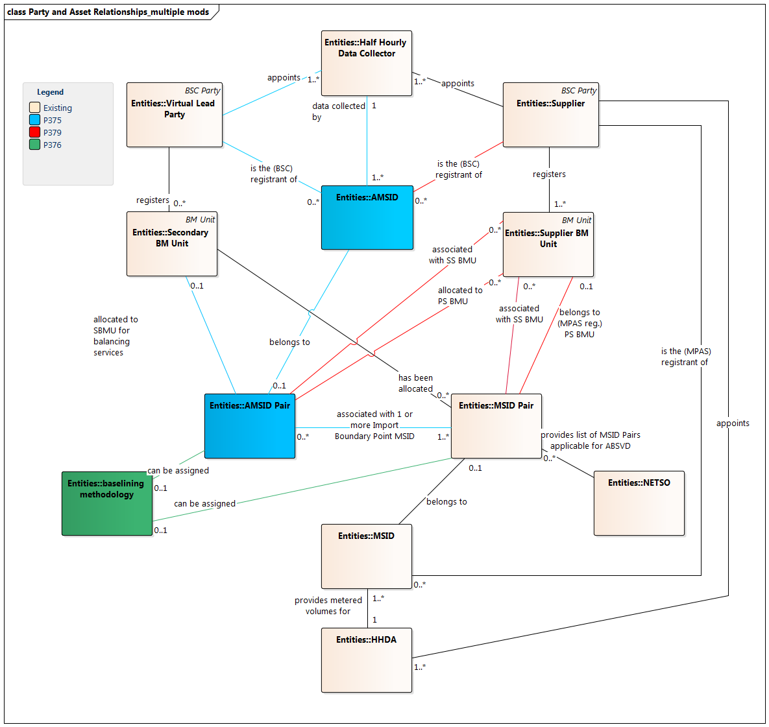

GLOSSARY

Term | Meaning

APPENDIX A P375 Requirements Metering Requirements for Asset Meters

Metering requirements for asset meters

Compliance Testing of Meters
BSCCo must publish and maintain a list of COP compliant Asset Meter make and models.

P375-BR14 | BSCCo must publish and maintain a list of COP compliant Asset Meter make and models.  Requirement Description  BSCCo will create and maintain the list of COP Compliant meters. The list will contain at least make and model of the metering device. BSCCo must use reasonable endeavours to ensure that the list is at all times publicly available on the BSC Website.  There must be at least one party that can dial the Asset Meter and has been protocol approved before that Asset Meter can be added the approved list.  All parties that can dial that Asset Meter Type will be listed under the protocol-approved section for the relevant Asset Meter type.
P375-BR15 | An Applicant must add a new Asset Meter make and model to the COP 11 Meter list.  Requirement Description  Where the Asset Metering System metering device is not listed under the COP11 approved list of devices, the applicant must contact the BSCCo to assess Metering System’s compliance.  The approval process will be laid out in one of the Code Subsidiary Documents.  The applicant can be any person, company or a party who wishes that a given device were added to the list.

Requirements to be replaced
The following requirement(s) are no longer valid and are superseded by the P379 solution.
P375-BR12 | SVAA should not allow AMSID to be registered for other processes than the P375 (e.g. such MSID cannot be registered against a Primary BM Unit).

Some P375 business requirements are replicated in this document to ensure they are captured if P375 is not approved and this Modification is.
As defined in the SVA Data Catalogue volume 2.
Defined in BSC Section X-2, Table X–6
Defined in BSC Section X-2, Table X–6.
This may seem like an unnecessary step, but in practice the Secondary Supplier could be the CNA, or have delegated the calculation of the volumes/percentages to the CNA (for example if the CNA is an asset management algorithm provider, or a trading platform)

